**Analyzing connectivity matrices without forcing into group atlas:**

**A multivariate approach**

Ju-Chi Yu1, Micaela Chan1,2, Han Liang1,2, Phillip Agres1,2 & Hervé Abdi1

1. School of Behavior and Brain Sciences, the University of Texas at Dallas

2. Center of Vital Longevity, the University of Texas at Dallas

[Ju-Chi.Yu@utdallas.edu](mailto:Ju-Chi.Yu@utdallas.edu), [mchan@utdallas.edu](mailto:mchan@utdallas.edu), [Liang.Han@utdallas.edu](mailto:Liang.Han@utdallas.edu), [Phillip.Agres@utdallas.edu](mailto:Phillip.Agres@utdallas.edu), [herve@utdallas.edu](mailto:herve@utdallas.edu)

**Abstract**

Recent work in resting-state functional magnetic resonance imaging (rsfMRI) analysis can derive individual-specific parcellations and sub-networks. Currently, DiSTATIS (Abdi et al., 2012)—a three-way multidimensional scaling (MDS)—is used to analyze rsfMRI data and to visualize the dissimilarity between networks. These dissimilarities were obtained by analyzing multiple distance matrices that have matching rows and columns (i.e., distinct functional regions in rsfMRI analysis). These functional regions are referred to as parcels or networks and are usually derived from a shared template onto which all data are mapped. However, using a shared template could bias the results against participants that vary greater from this template, and this issue is particularly problematic amongst participants with diverse brain structures and functions (e.g., elderly, lesion patients, children). For such participants, the optimal parcellation would be the one that maximizes the homogeneity of the signal within each parcel region and of each participant. Thus, the goal of this project is to propose a multivariate approach that accommodates differing parcel numbers and organizations across subjects.

**Methods**

The proposed multivariate approach (see Fig. 1) first extracts the upper-triangle of the connectivity matrix of each participant session and vectorize it to form the rows of a data table. Sessions from the same participant are stacked to form a block of columns. Each participant's block is placed adjacent to one another to form the final data table, where the rows are session and the columns are network edges. Next, hierarchical multiple factor analysis (Abdi et al., 2013; Le Dien & Pagès, 2003) is used to preprocess the data table by normalizing each participant’s column-block by its first singular value, then dividing the column block of each edge-type (i.e., between- or within-network) within each participant’s column block by its first singular value. Finally, a PCA is performed to visualize the edges, participants, and sessions.

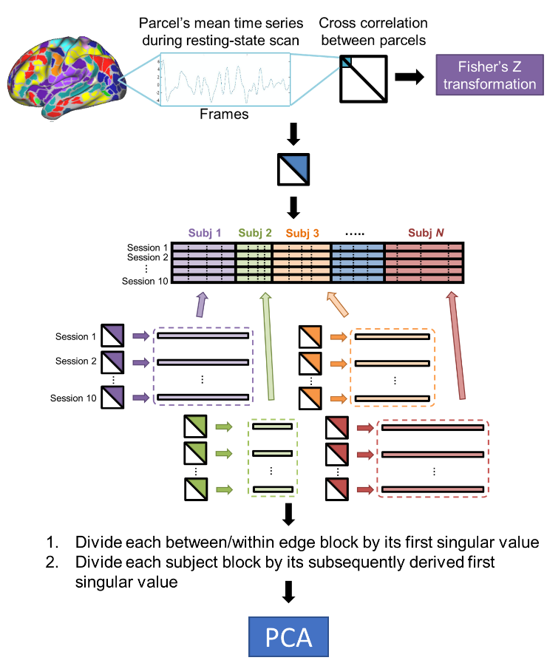

**Fig. 1**

To test this new technique, the Midnight Scan Club (MSC) dataset (Gordon et al., 2017) was obtained from the OpenfMRI database (accession number ds000224). This dataset was chosen because MSC has adequate rsfMRI data to produce individualized parcellation (i.e., 30 min × 10 sessions). Individual-specific functional parcellation was available for each participant (Gordon et al., 2017), and the functional connectivity between two regions was computed by the Fisher’s *Z*-transformed correlation of their BOLD signals. Thus, the whole-brain functional connectivity of each session of each participant can be represented by a symmetric, region-by-region connectivity matrix. From the original MSC data, only four sessions for each participant were selected. For Sessions 2 and 4, the connectivity of three types of edges was decreased by half to simulate an inhibitory effect of connectivity: edges (1) within the default mode network (DMN), (2) between DMN and the frontoparietal network (FPN), and (3) between DMN and the dorsal attention network (DAN).

**Results**

This new multivariate approach to analyzing the MSC data table showed that the simulated sessions (2 & 4) are separated from the non-simulated ones (1 & 3) on the first component (Fig. 2A), and this separation is driven by the within DMN connectivity and several other between-network edges, including edges between DMN and DAN (Fig. 2B).

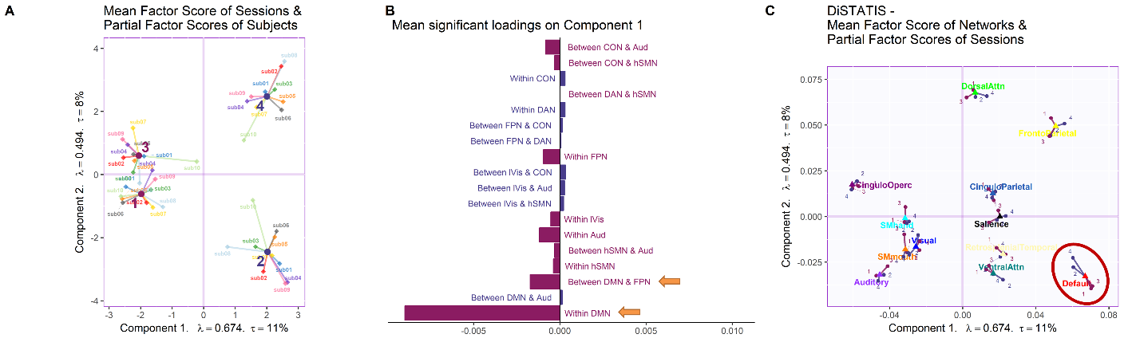

**Fig. 2**

A comparison analysis was conducted using DiSTATIS, where data were mapped to a shared template (Gordon et al., 2016). While DiSTATIS also showed the session effect in DMN (Fig. 2C), between-network effect could not be illustrated.

In conclusion, this technique provides a multivariate approach to analyze functional connectivity with individual parcellation and is particularly useful when the connectivity is extracted from a participant group with diverse brain sizes, parcellation or organizations.

**References *** Put the names of the Journal for all references \*\*\*\***

Abdi, H., Williams, L.J., Valentin, D. (2013) Multiple factor analysis: principal component analysis for multitable and multiblock data sets. ******* 5:149-179.

Abdi, H., Williams, L.J., Valentin, D., Bennani-Dosse, M. (2012) STATIS and DISTATIS: optimum multitable principal component analysis and three way metric multidimensional scaling. ********4:124-167.

Gordon, E.M., Laumann, T.O., Adeyemo, B., Huckins, J.F., Kelley, W.M., Petersen, S.E. (2016) Generation and Evaluation of a Cortical Area Parcellation from Resting-State Correlations. *Cerebral Cortex, 26*:288-303.

Gordon, E.M., Laumann, T.O., Gilmore, A.W., Newbold, D.J., Greene, D.J., Berg, J.J., Ortega, M., Hoyt-Drazen, C., Gratton, C., Sun, H., Hampton, J.M., Coalson, R.S., Nguyen, A.L., McDermott, K.B., Shimony, J.S., Snyder, A.Z., Schlaggar, B.L., Petersen, S.E., Nelson, S.M., Dosenbach, N.U.F. (2017) Precision Functional Mapping of Individual Human Brains. *Neuron, 95*:791-807.e7.

Le Dien, S., Pagès, J. (2003) Hierarchical Multiple Factor Analysis: application to the comparison of sensory profiles. *Food Quality and Preference, 14*:397-403.